**Standard Operating Procedure (SOP)** **Streamlit Student Career Exploration App**

**Objective:** To provide a step-by-step guide for operating the Streamlit web application that assists students in exploring their academic career options and accessing college details.

**Step 1: Import Libraries**

* Import the required Python libraries, including Pandas, Streamlit, boto3 (for AWS S3 interaction), PIL (Python Imaging Library), and others. 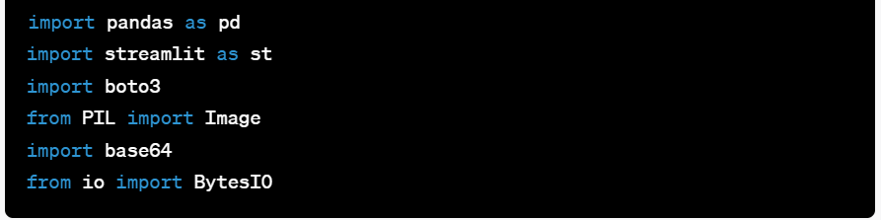

**Step 2: Fetch Data**

* Define the URL of the Google Sheets document containing student data.
* Modify the URL to the export format.
* Use Pandas to read the data from the URL and load it into a Pandas DataFrame.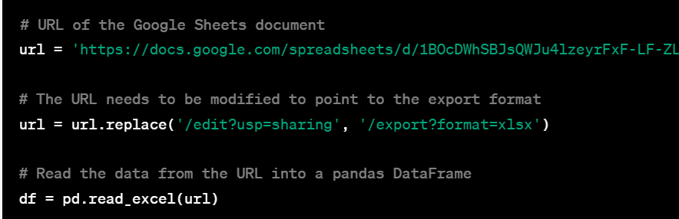

**Step 3: Load Image**

* Set up access credentials (AWS Access Key and AWS Secret Key).
* Connect to an AWS S3 bucket.
* Retrieve an image file from the S3 bucket.
* Convert the image to a base64-encoded string for display.

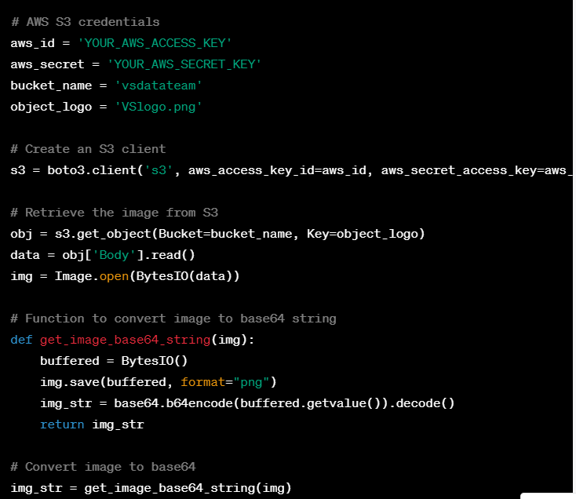

**Step 4: Define Streamlit Interface**

* Create the main user interface using Streamlit.
* Allow users to input their name.
* Provide options for selecting their academic aspirations, including degree, field, subfield, and college.
* Display a warning if the name is not entered.

**Step 5: Explore Career Button**

* When the "Explore Career" button is clicked:
* Set a session state variable to indicate that the next page (**Job12.py**) should be displayed.
* Rerun the Streamlit script to handle the next page.

**Step 6: Display Next Page (Job12.py)**

* Check if the session state variable indicates that the next page should be displayed.
* If yes, import the **Job12.py** module.
* Execute the **main()** function from **Job12.py** to display additional content.
* If no, continue displaying the main page.

**Step 7: Conclusion**

* The SOP outlines the procedure for operating the Streamlit Student Career Exploration web application.
* The **Job12.py** page handles additional functionality and should be described in a separate document or SOP.

Top of Form